Student Name

HL9X35 Test Documentation

Contents
Test Strategy 2
Automated Tests 2
Documentation of Test Runs 2
Manual Tests 5
Completed GUI Documentation 5

Test Strategy

For this project I will be performing both Unit Testing on business logic of my system, and also User Testing to validate the GUI portion of my system.
To Unit Test the business logic I will use a suite of automated tests created using JUnit. A listing of these tests is included in the section Automated Tests.
- Why am I using this strategy?
- What is the advantage of using this strategy?
- What are any disadvantages of using this strategy?
To validate the GUI I will carry out manual testing. The tester will be provided with a set of tests to carry out, along with any input data required, and will validate that the GUI performs as expected. The documentation for these tests can be found in the section Manual Tests.
- Why am I using this strategy?
- What is the advantage of using this strategy?
- What are any disadvantages of using this strategy?

Automated Tests
The following table list the automated tests which have been created to test the business logic of the XX system. The tests themselves can be found as part of the XX Project code base.
- These tests should at a minimum cover the required tests listed in the task instructions.
- The description should make clear the reason for the test, what it is testing, and what the criteria for pass and fail are
No | Test Name | Description
1 | testPrepopulatedUsers | Tests that on initial startup the system has been prepopulated with 9 users.  Pass: on startup 9 prepopulated users exist  Fail: on startup 9 prepopulated users do not exist
etc

Documentation of Test Runs

Test Run 1: 29-04-20 12.32pm
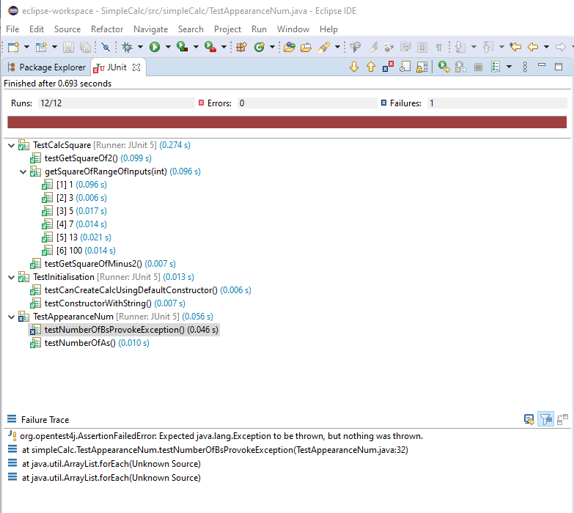

Evaluation:
Test 6 ‘testNumberOfBsProvokeException’ failed in this run. The expected exception was not generated. On investigation it was discovered that the test to decide whether or not to throw the exception was flawed due to incorrect handling of upper and lower case input data. This was corrected to test for both upper and lower case data.

Test Run 2: 29-04-20 12.42pm
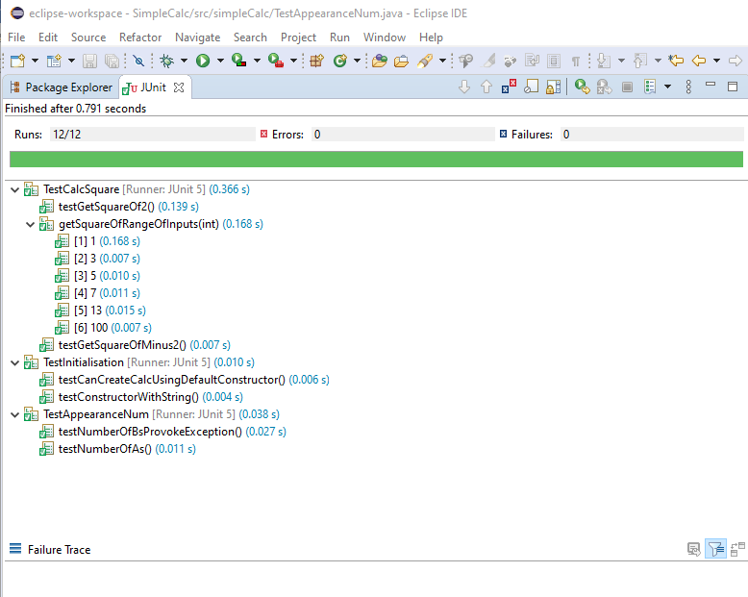

Evaluation
After the previous corrections were completed, all tests passed. The system is now considered ready for User Testing

Manual Tests
The following table lists the manual tests to be performed by a User to verify that the system GUI works as expected. This table provides the instructions to the user and any input data the user will need. While running these tests, the user completed the questionnaire in Section X, to document their results.
No | Test Instruction | Test Data
1 | Log in as an administrator | Username: “admin”  Password: “admin”
2 | Log in with incorrect credentials. | Username: “admin”  Password: “nonsense”
3 | Logged in as administrator, request to show all users
etc

Completed GUI Documentation

Task | Please rate your experience of each task  1 = Strongly Negative, 5 = Strongly Positive | Any Comments/Recommendations?
Login As An Administrator | 1 2 3 4 5
Failed Login | 1 2 3 4 5 | Was allowed to retry login, but error message could have been clearer
View All Users | 1 2 3 4 5
etc | 1 2 3 4 5
 | 1 2 3 4 5
 | 1 2 3 4 5
 | 1 2 3 4 5
 | 1 2 3 4 5
 | 1 2 3 4 5
 | 1 2 3 4 5

Evaluation
Although some minor UI issues were logged by the User, all tests passed. UI comments have been logged for consideration as enhancements in a future release.

